

06 - Strings in Python

Department of Computer Science and Engineering

| Rajalakshmi Engineering College

PA. GE

Ex. No. : 6.1 Date: 04.05.2024

Register No.: 231401020 Name: BHUVANESWARI S

Count Chars

Write a python program to count all letters, digits, and special symbols respectively from a given string

For example:

Input Result
rec@123

3
3

1

a=input()
c,d,s=0,0,0

for i in range(len(a)):

if(a[i].isalpha()):

c+=1
elif(a[i].isdigit()):

d+=1
else:

s+=1
print(c,d,s,sep="\n")

Department of Computer Science and Engineering | Rajalakshmi Engineering College

PA.

GE

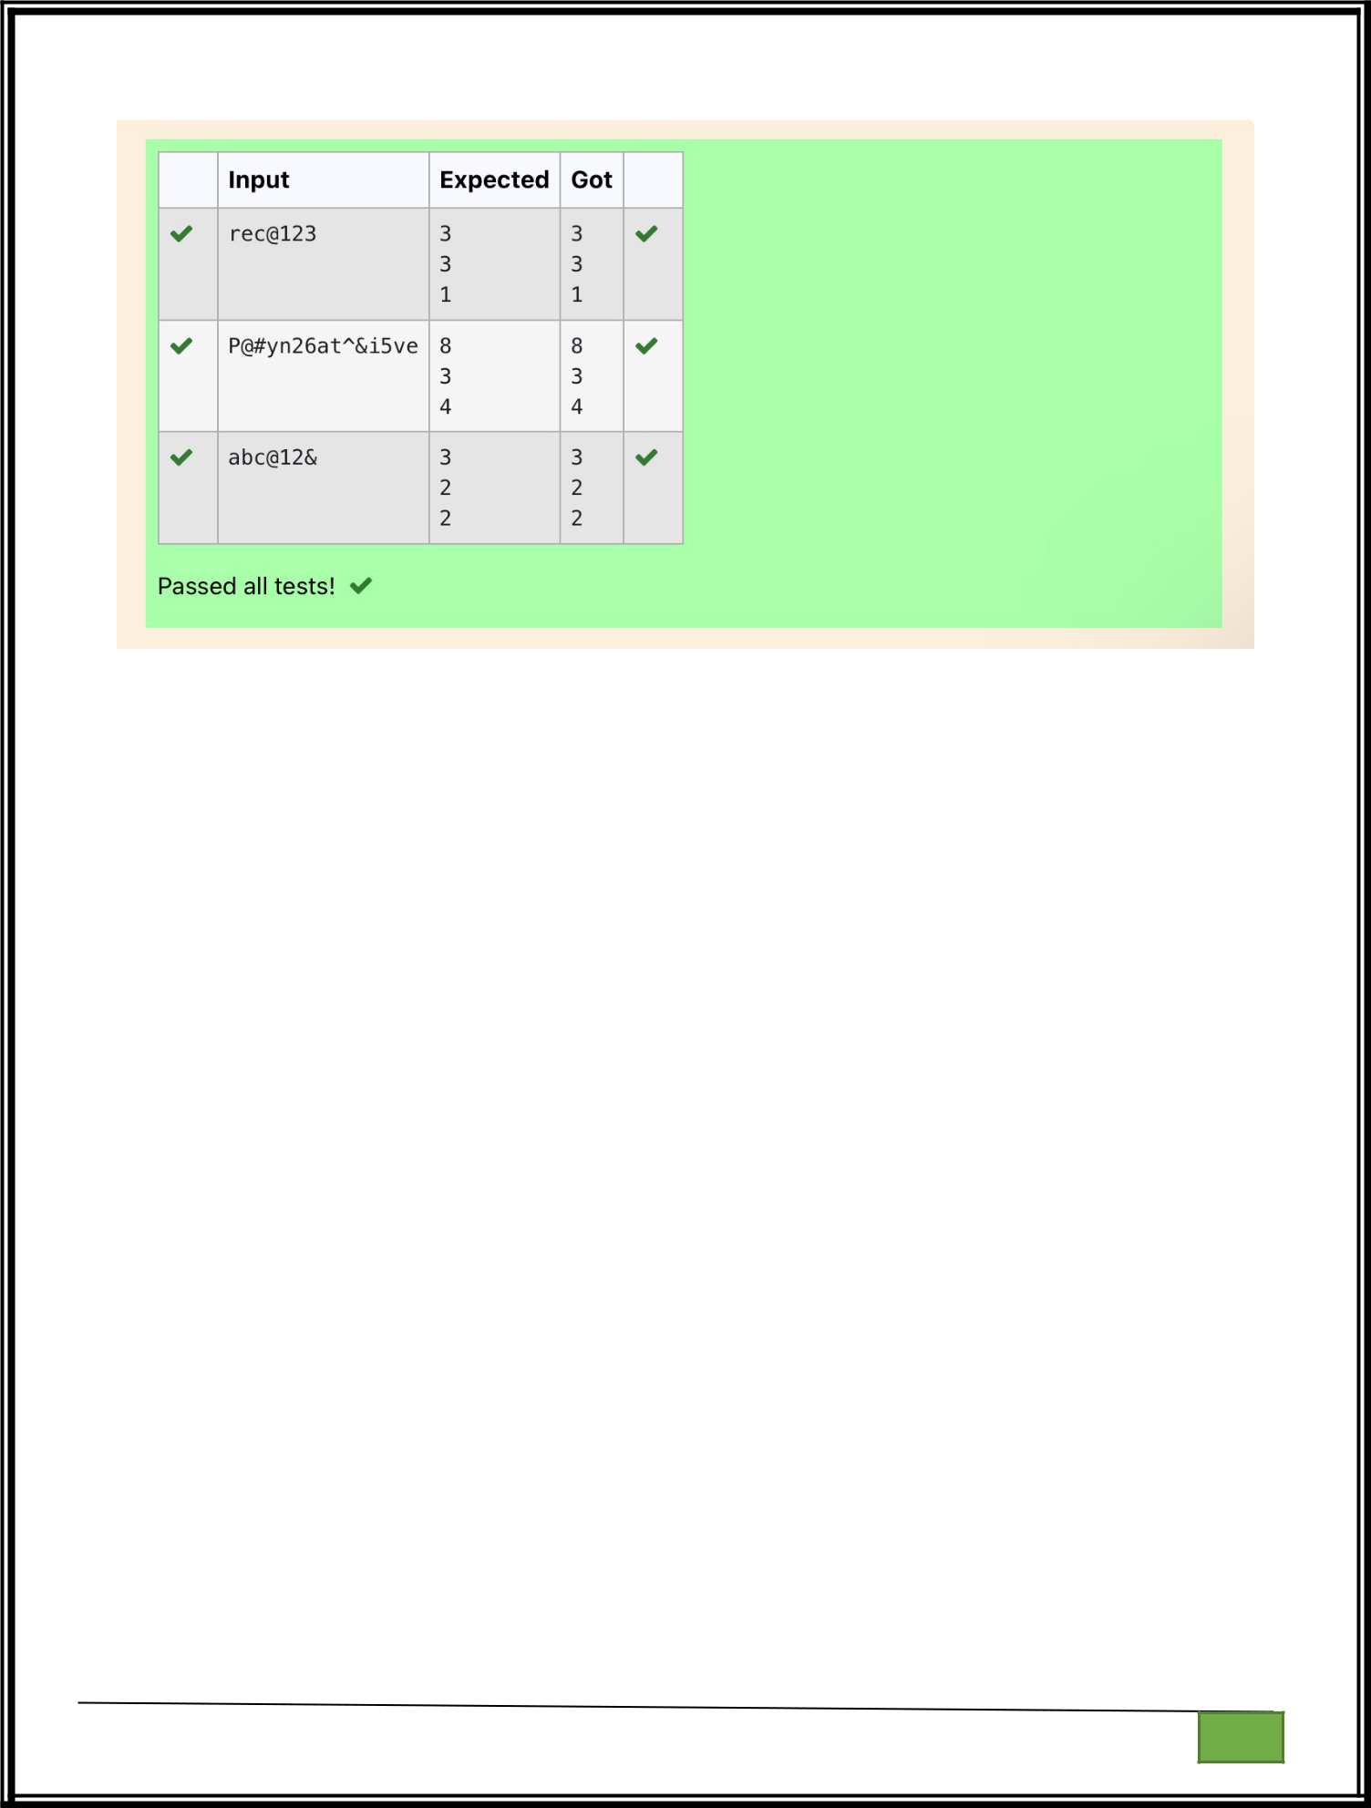

Department of Computer Science and Engineering

| Rajalakshmi Engineering College

PA. GE

Department of Computer Science and Engineering

| Rajalakshmi Engineering College

PA. GE

Ex. No.

:

6.2

Date: 04.05.2024
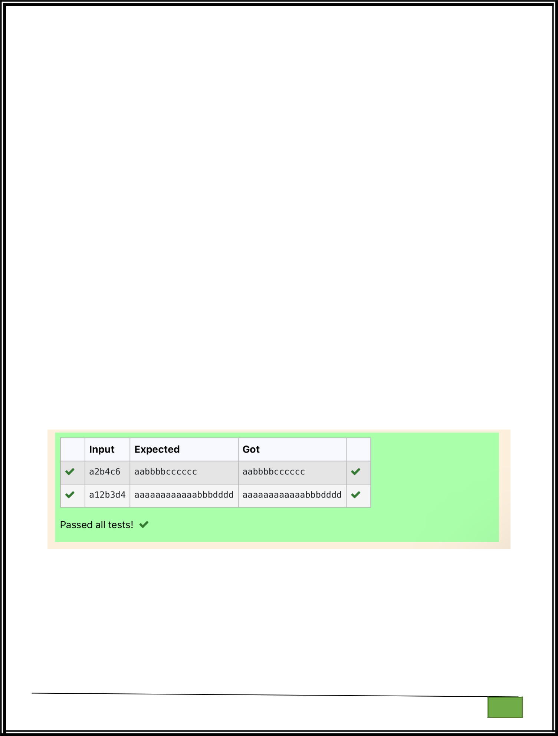

Register No.: 231401020

Name: BHUVANESWARI S

Decompress the String

Assume that the given string has enough memory. Don't use any extra space(IN-PLACE)

Sample Input 1
a2b4c6

Sample Output 1

aabbbbcccccc

import re

a=input()
all=re.findall('\d+',a)

all_w=re.findall('[a-z]',a)
b=''

for i,j in zip(all,all_w):
b+=int(i)*j

print(b)

Department of Computer Science and Engineering

| Rajalakshmi Engineering College

PA. GE

Department of Computer Science and Engineering

| Rajalakshmi Engineering College

PA. GE
Ex. No. : 6.3 Date: 04.05.2024

Register No.: 231401020 Name: BHUVANESWARI S

First N Common Chars
Two string values S1, S2 are passed as the input. The program must print first N characters present in S1 which are also present in S2.

Input Format:

The first line contains S1.
The second line contains S2.

The third line contains N.

Output Format:

The first line contains the N characters present in S1 which are also present in S2.

Boundary Conditions:

2<=N<=10
2 <= Length of S1, S2 <= 1000

Example Input/Output 1:

Input:

abcbde

cdefghbb
3

Output:

bcd

Note:

b occurs twice in common but must be printed only once.

a=input()
b=input()

C=''

Department of Computer Science and Engineering | Rajalakshmi Engineering College

PA.

GE

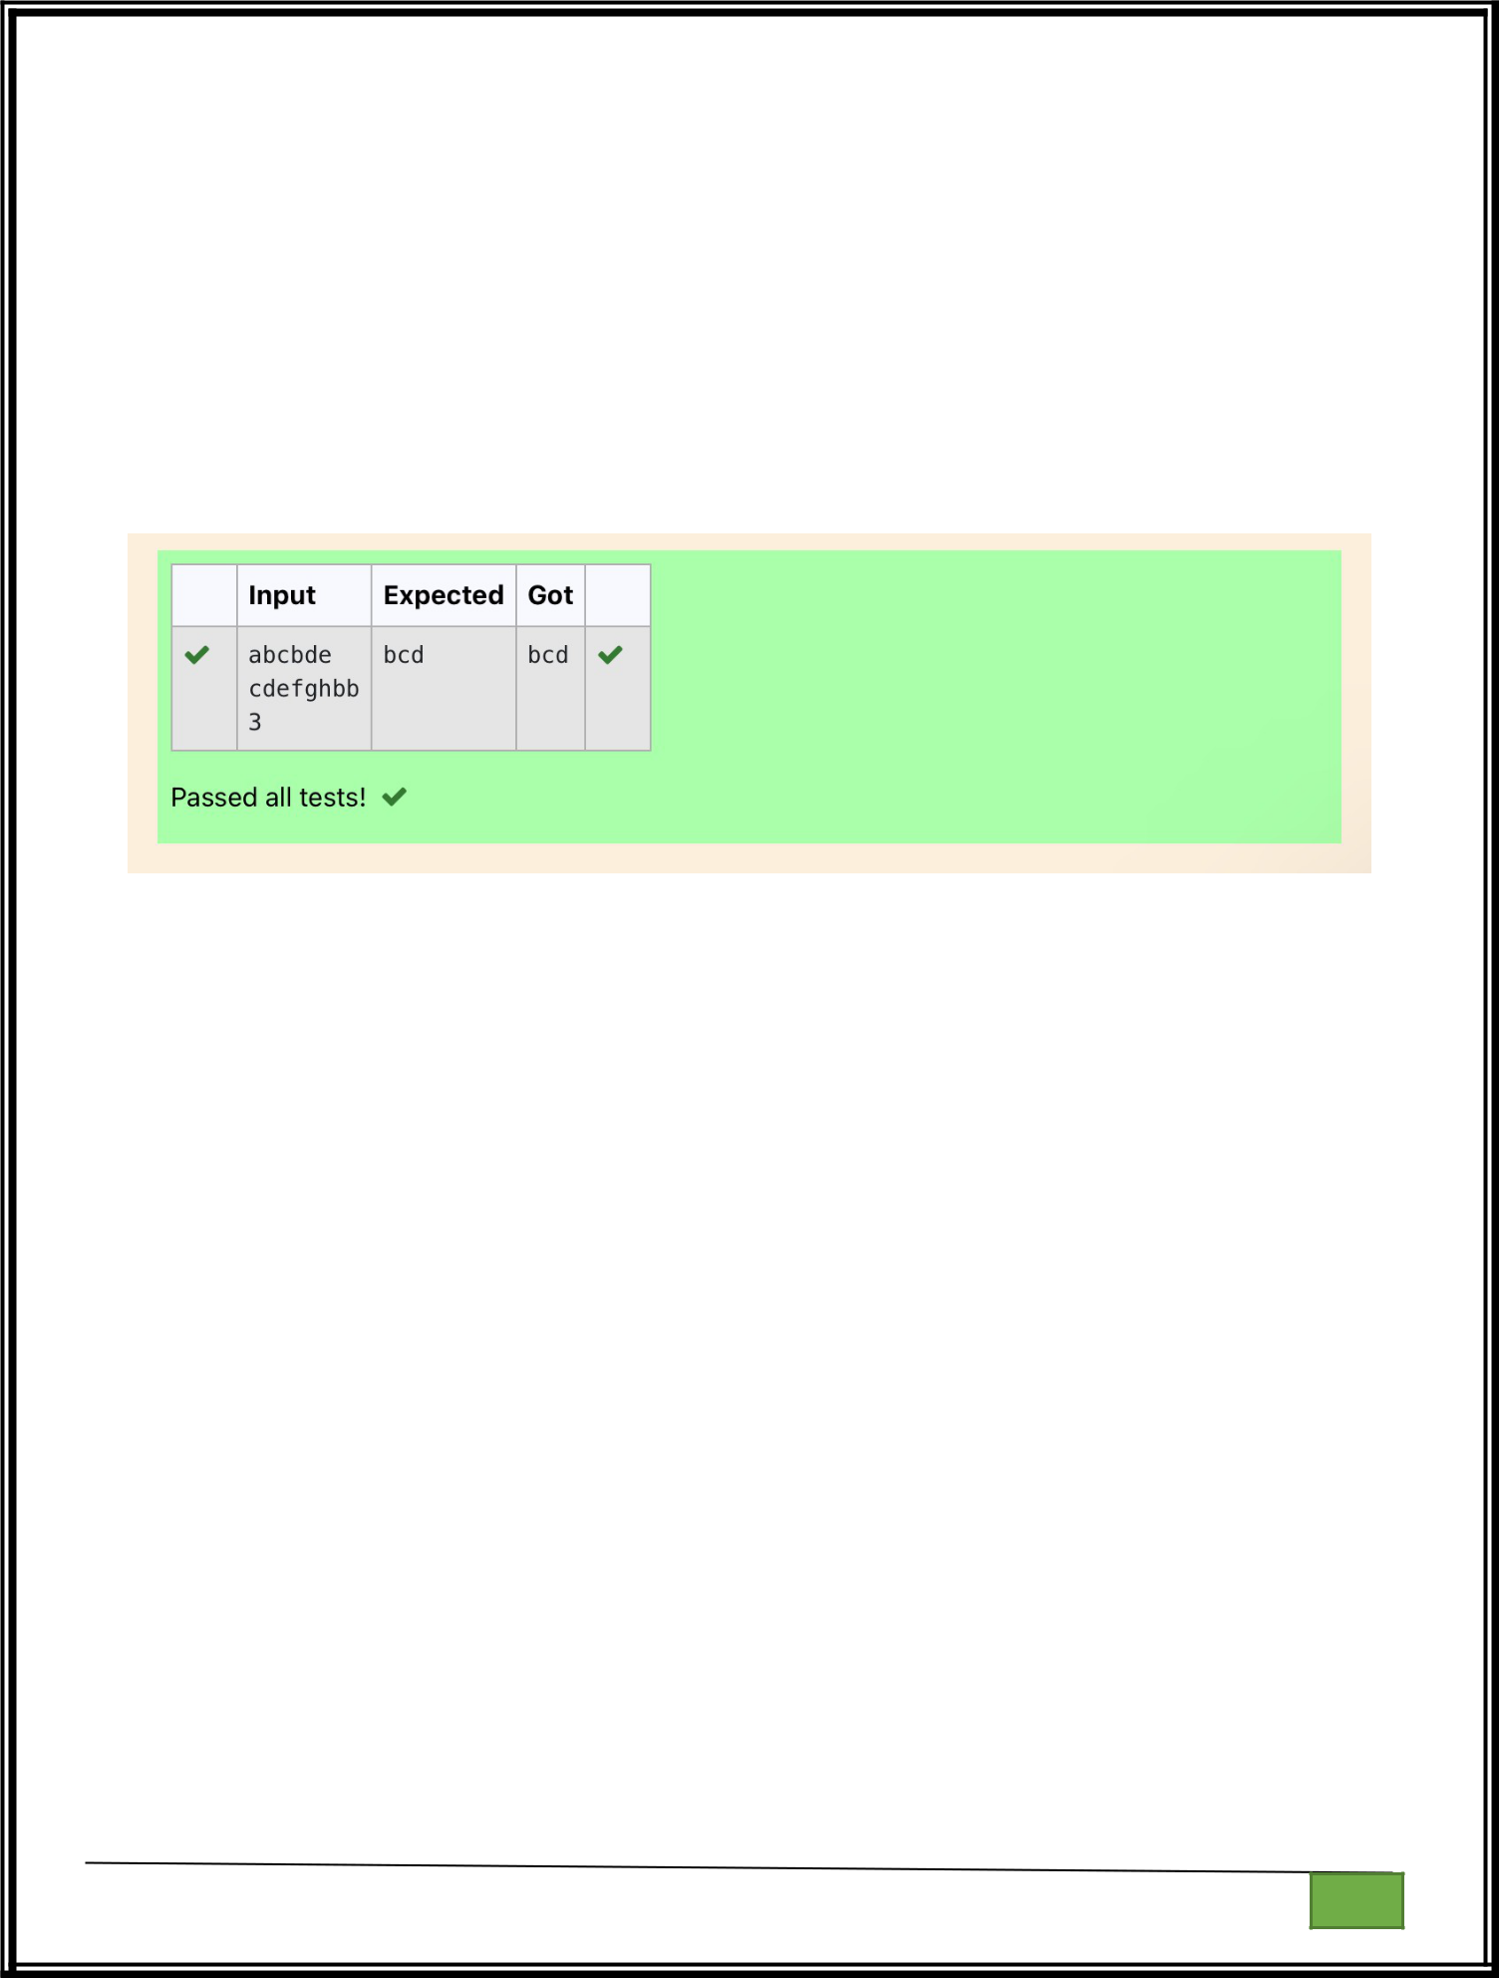
d=int(input())
for i in range(len(a)):

if(len(C)-d==0):
break

else:
if(a[i]in b):

if(a[i] not in C):
C+=a[i]

print (C)

Department of Computer Science and Engineering

| Rajalakshmi Engineering College

PA. GE

Department of Computer Science and Engineering

| Rajalakshmi Engineering College

PA. GE
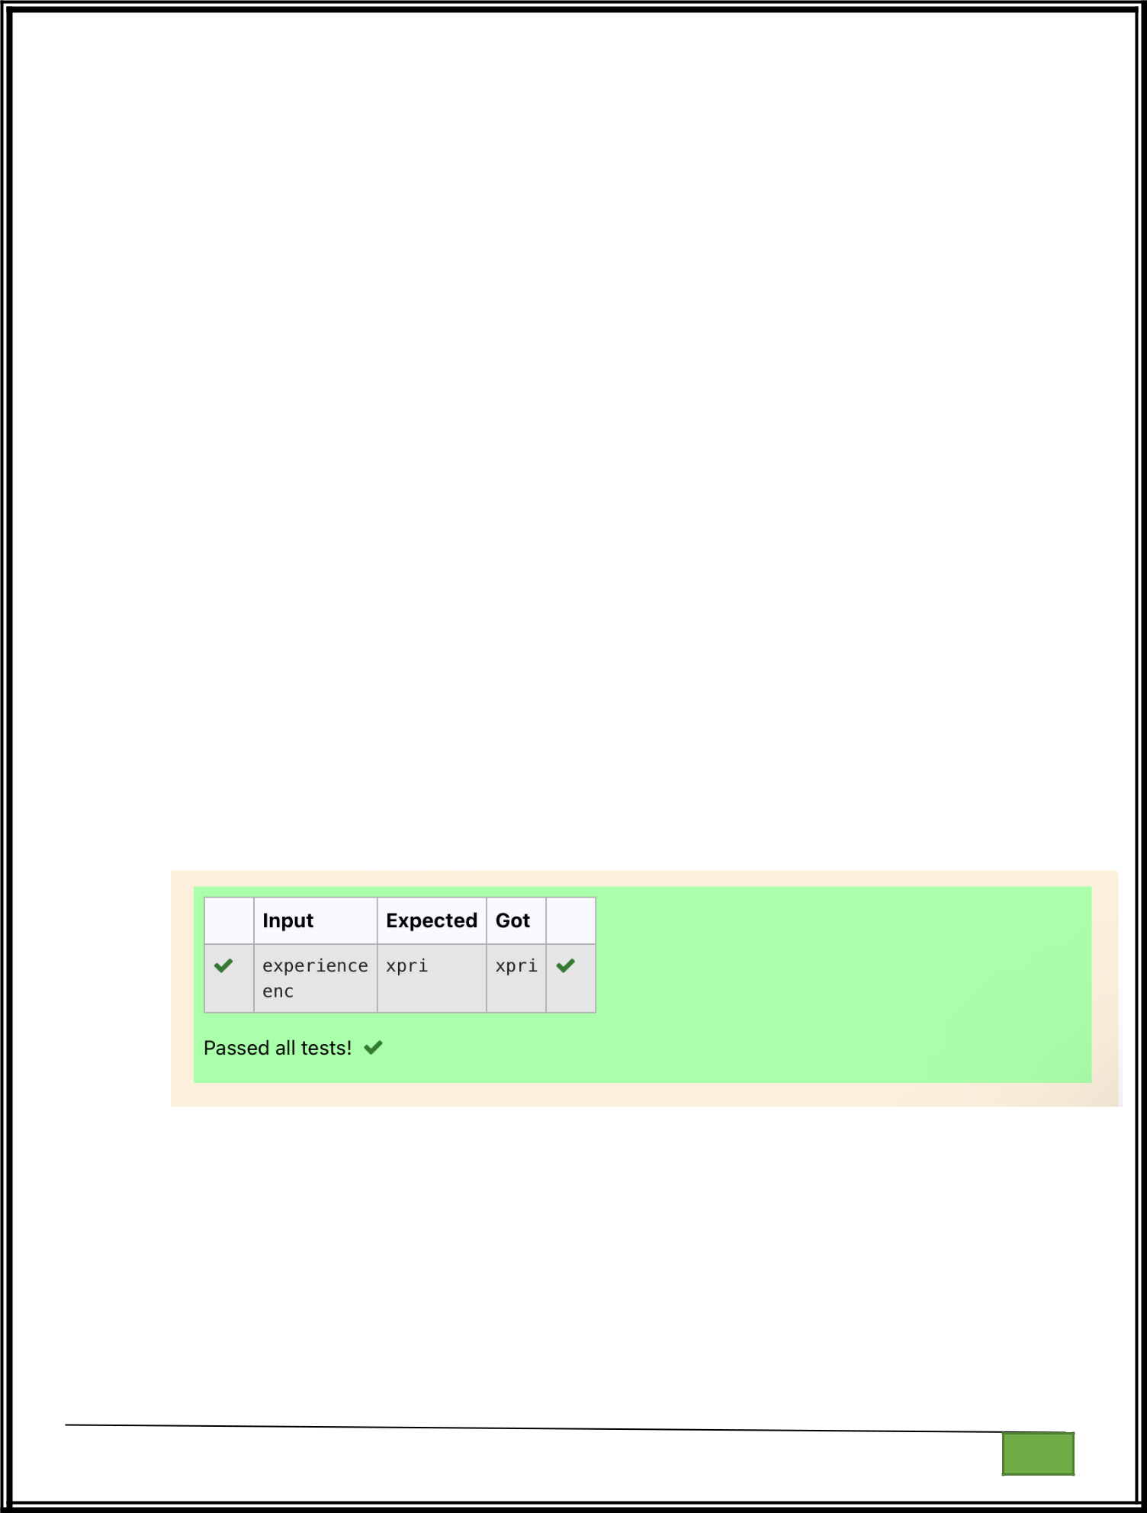
Ex. No. : 6.4 Date: 04.05.2024

Register No.: 231401020 Name: BHUVANESWARI S

Remove Characters
Given two Strings s1 and s2, remove all the characters from s1 which is present in s2. Constraints
1<= string length <= 200
Sample Input 1

experience
enc

Sample Output 1

xpri

def remove_chars(s1, s2):

return ''.join([char for char in s1 if char not in s2])
s1=input()

s2=input()
result = remove_chars(s1, s2)

print(result)

Department of Computer Science and Engineering | Rajalakshmi Engineering College

PA.

GE

Department of Computer Science and Engineering

| Rajalakshmi Engineering College

PA. GE
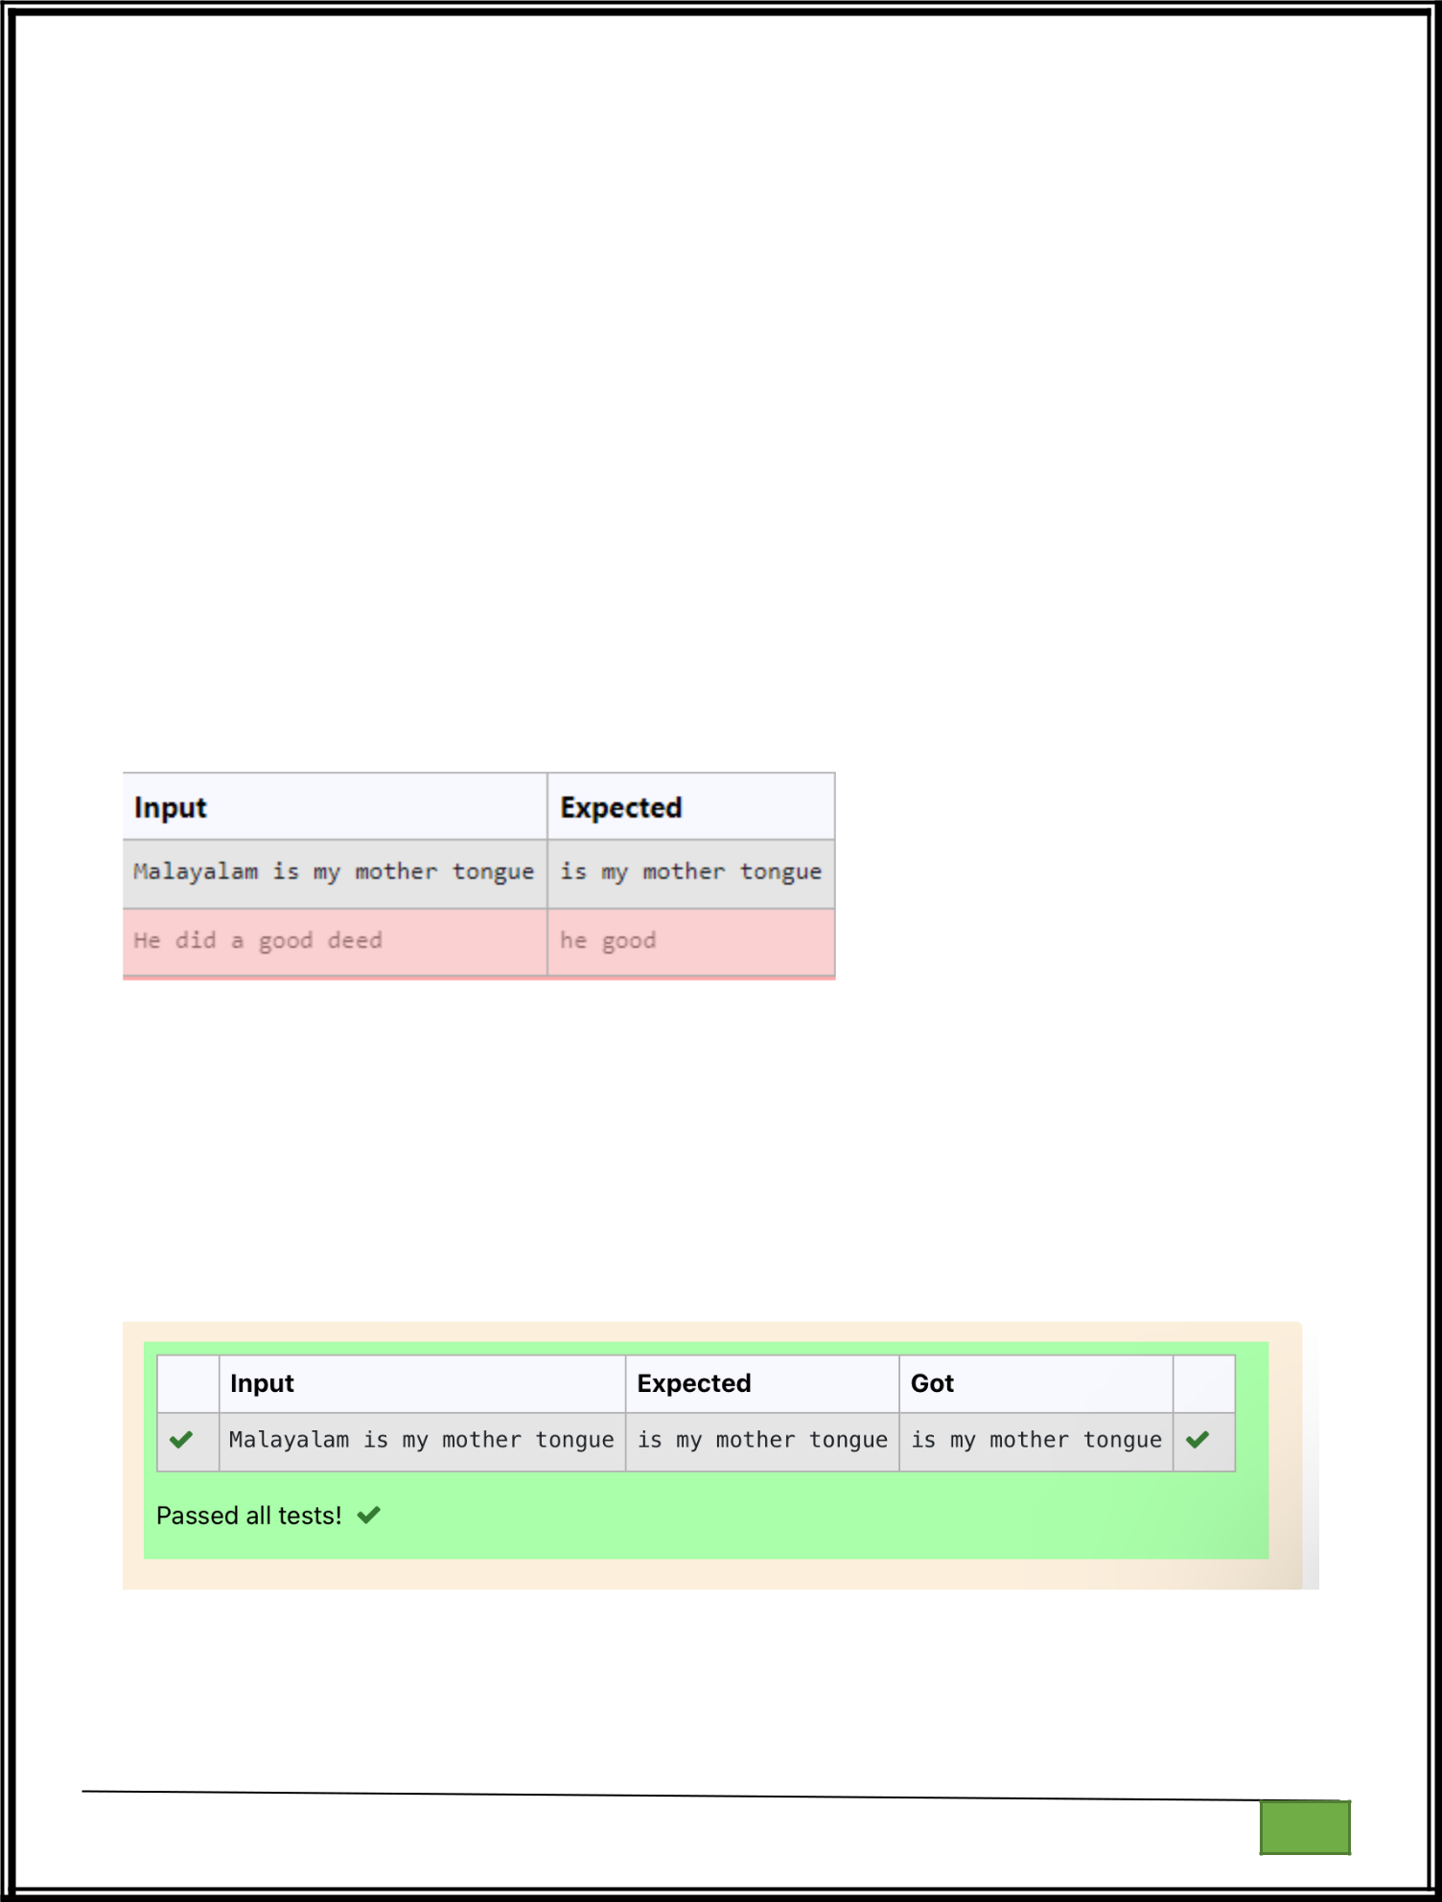
Ex. No. : 6.5 Date:

Register No.: 231401020 Name: BHUVANESWARI S

Remove Palindrome Words
String should contain only the words are not palindrome.

Sample Input 1

Malayalam is my mother tongue

Sample Output 1
is my mother tongue

For example:

a=[]

a=input()
b=a. split()

for i in b:
k=i.lower()

if k!=k[::-1]:
print(k,end=' ')

Department of Computer Science and Engineering | Rajalakshmi Engineering College

PA.

GE

Department of Computer Science and Engineering

| Rajalakshmi Engineering College

PA. GE
Ex. No. : 6.6 Date: 04.05.2024

Register No.: 231401020 Name: BHUVANESWARI S

Return Second World in Uppercase

Write a program that takes as input a string (sentence), and returns its second word in uppercase.

For example:

If input is “Wipro Technologies Bangalore” the function should return “TECHNOLOGIES”

If input is “Hello World” the function should return “WORLD” If input is “Hello” the program should return “LESS”

NOTE 1: If input is a sentence with less than 2 words, the program should return the word “LESS”.

NOTE 2: The result should have no leading or trailing spaces.

For example:

Input Result
Wipro Technologies Bangalore

TECHNOLOGIES
Hello World

WORLD
Hello

LESS

f=input()
s=f.split()

if len(s)>1:
c=s[1]

print(c.upper())
else:

print("LESS")

Department of Computer Science and Engineering | Rajalakshmi Engineering College

PA.

GE

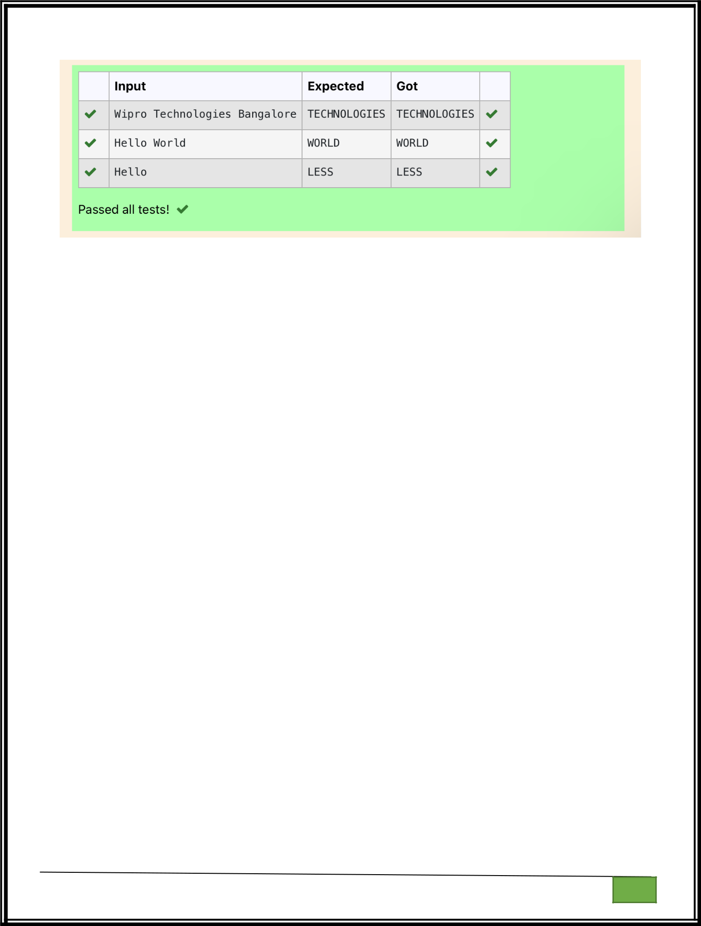

Department of Computer Science and Engineering

| Rajalakshmi Engineering College

PA. GE

Department of Computer Science and Engineering

| Rajalakshmi Engineering College

PA. GE
Ex. No. : 6.7 Date: 04.05.2024

Register No.: 231401020 Name: BHUVANESWARI S

Revers String
Reverse a string without affecting special characters. Given a string S, containing special characters and all the alphabets, reverse the string without affecting the positions of the special characters.

Input:

A&B
Output:

B&A
Explanation: As we ignore '&' and

As we ignore '&' and then reverse, so answer is "B&A".

For example:

Input Result

A&x#
x&A#

def reverse_string(s):

s = list(s)
l, r = 0, len(s) - 1

while l < r:

if not s[l].isalpha():
l += 1

elif not s[r].isalpha():
r -= 1

else:
s[l], s[r] = s[r], s[l]

l += 1
r -= 1

return ''.join(s)

# Test Cases

print(reverse_string(input())) # Output: "B&A"

Department of Computer Science and Engineering | Rajalakshmi Engineering College

PA.

GE

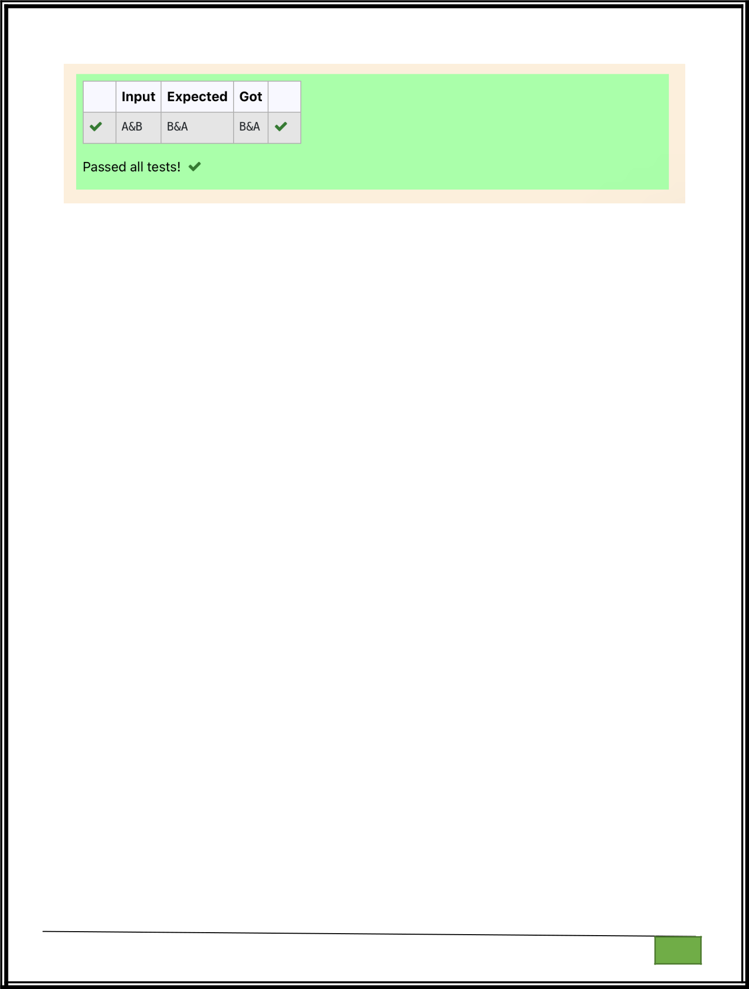

Department of Computer Science and Engineering

| Rajalakshmi Engineering College

PA. GE

Department of Computer Science and Engineering

| Rajalakshmi Engineering College

PA. GE
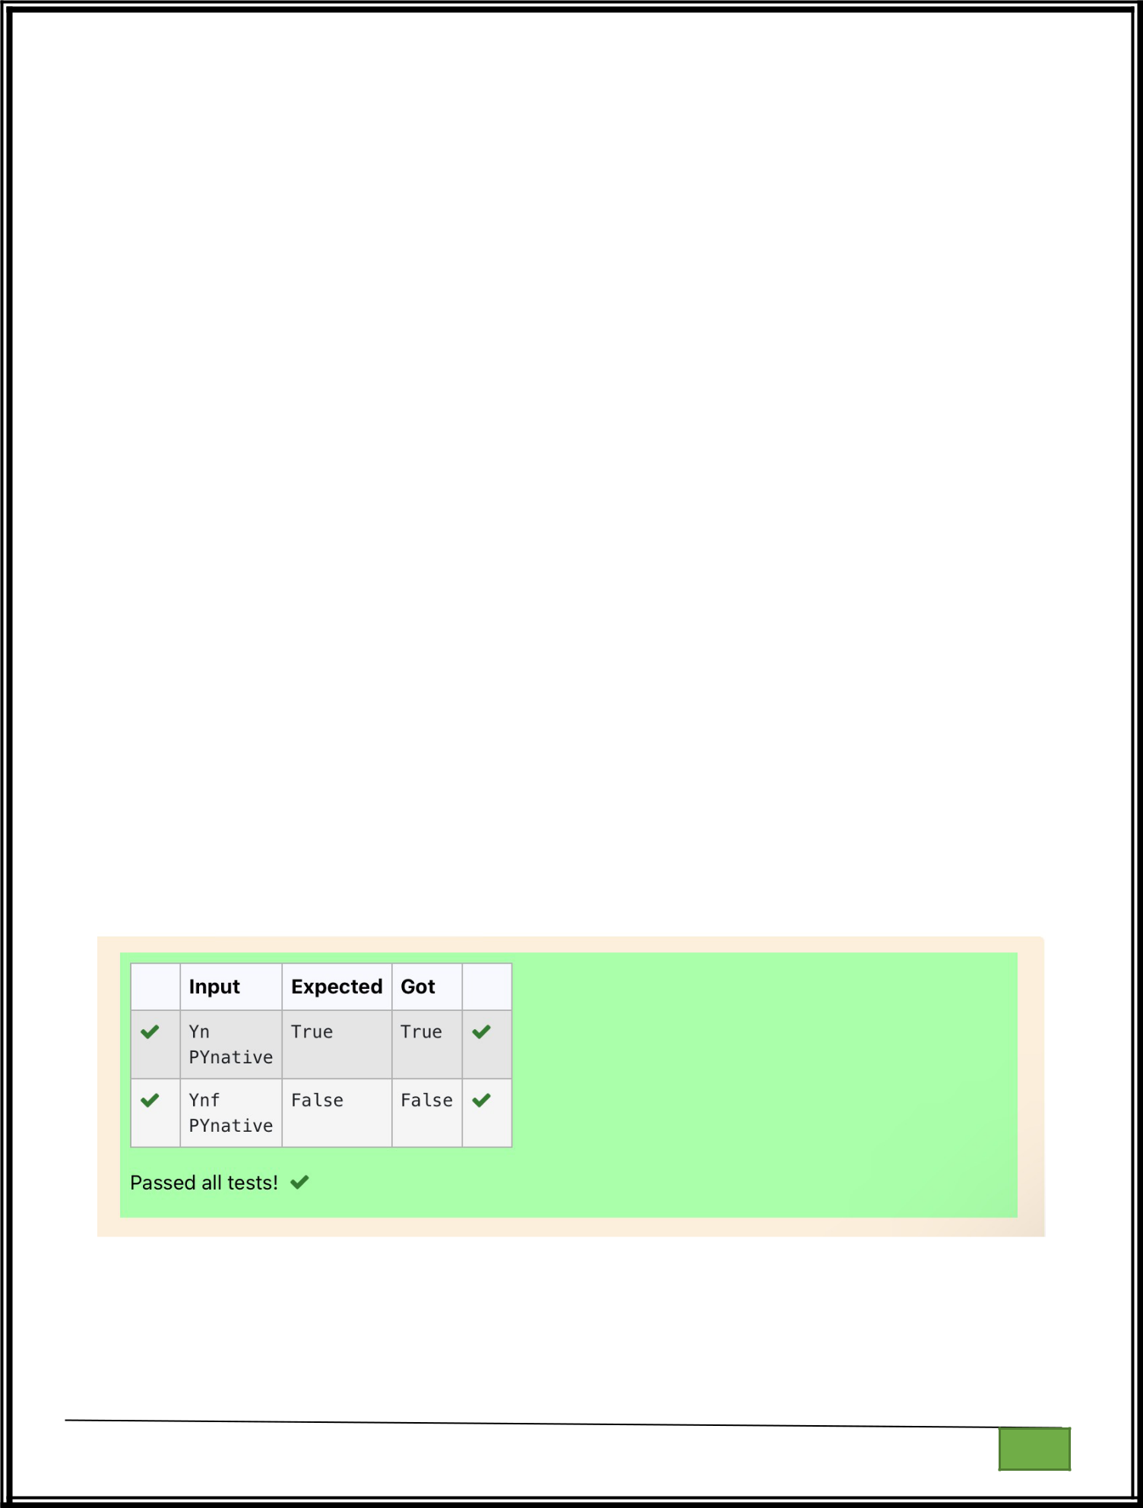
Ex. No. : 6.8 Date: 04.05.2024

Register No.: 231401020 Name: BHUVANESWARI S

String characters balance Test

Write a program to check if two strings are balanced. For example, strings s1 and s2 are balanced if all the characters in the s1 are present in s2. The character’s position doesn’t matter. If balanced display as "true" ,otherwise "false".

For example:

Input Result
Yn

PYnative
True

a=input()

b=input()
if a in b:

print("True")
else:

print("False")

Department of Computer Science and Engineering | Rajalakshmi Engineering College

PA.

GE

Department of Computer Science and Engineering

| Rajalakshmi Engineering College

PA. GE
Ex. No. : 6.9 Date: 04.05.2024

Register No.: 231401020 Name: BHUVANESWARI S

Unique Names

In this exercise, you will create a program that reads words from the user until the user enters a blank line. After the user enters a blank line your program should display each word entered by the user exactly once. The words should be displayed in the same order that they were first entered. For example, if the user enters:
Input:
first

second
first

third
second

then your program should display:

Output:
first
second

third

a,c=[],[]

for i in range(0,5):
b=input()

a.append(b)
for i in range(len(a)):

if(a[i] not in c):
c.append(a[i])

print(a[i])

Department of Computer Science and Engineering | Rajalakshmi Engineering College

PA.

GE

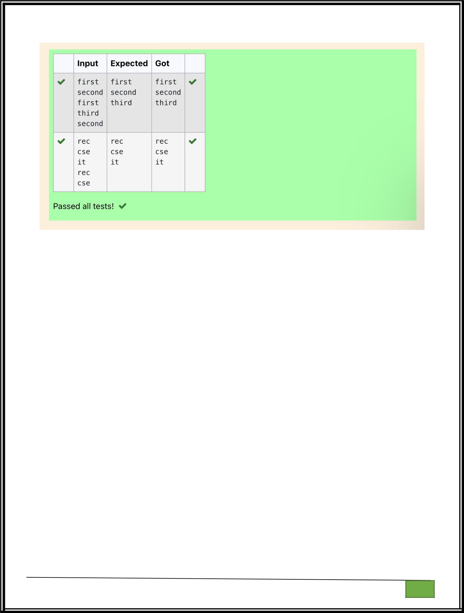

Department of Computer Science and Engineering

| Rajalakshmi Engineering College

PA. GE

Department of Computer Science and Engineering

| Rajalakshmi Engineering College

PA. GE
Ex. No. : 6.10 Date: 04.05.2024

Register No.: 231401020 Name: BHUVANESWARI S

Username Domain Extension

Given a string S which is of the format USERNAME@DOMAIN.EXTENSION, the program must print the EXTENSION, DOMAIN, USERNAME in the reverse order.

Input Format:
The first line contains S.

Output Format:

The first line contains EXTENSION.
The second line contains DOMAIN.

The third line contains USERNAME.

Boundary Condition:
1 <= Length of S <= 100

Example Input/Output 1:

Input:

vijayakumar.r@rajalakshmi.edu.in

Output:

edu.in

rajalakshmi
vijayakumar.r

a = input()

ext = a.split('@')[0]

dom = a.split('@')[1].split('.')[0]

userno = a.find('.')

user = a[userno+1:]

print(user)

print(dom, end='\n')

Department of Computer Science and Engineering | Rajalakshmi Engineering College

PA.

GE

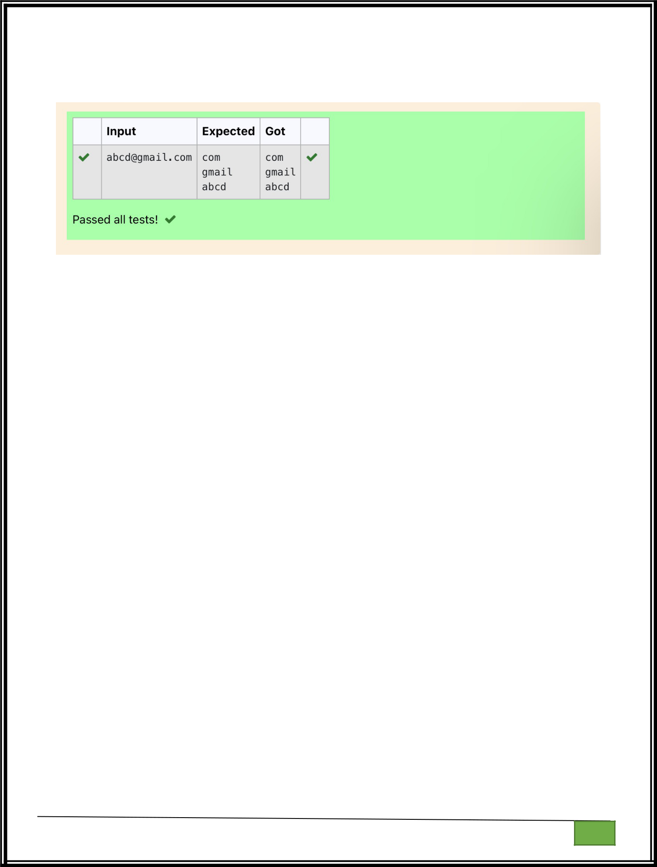
print(ext,end='\n')

Department of Computer Science and Engineering

| Rajalakshmi Engineering College

PA. GE

